Paper title
Paper Subtitle
THEMATIC SESSION: INDICATE THE NAME OF ONE OF THE EVENT'S THEMATIC SESSIONS
CATEGORY: INDICATE THE TYPE OF COMMUNICATION - SCIENTIFIC ACADEMIC ARTICLE OR ARTICLE ON PRACTICAL/PROFESSIONAL WORK

Autor 1: Name/institutional affiliation/Email
Autor 2: Name/institutional affiliation/Email
Autor 3: Name/institutional affiliation/Email

ABSTRACT
This paper outlines the format for submitting an article to the 7th CIAP. The abstract, which is required, should be no more than 200 (two hundred) words long and written in a single paragraph. The abstract ought to describe the problem studied, the objective(s), the method(s), and the main conclusions or results. The work submitted must be previously unpublished. The accepted essay will be reproduced exactly as submitted by the author(s); therefore, grammatical proofreading is the submitter's entire responsibility. A paper that does not follow these requirements will be rejected. The paper may be presented at the event and/or published in the proceedings. Three to five keywords are required.

KEYWORDS: model; format template; landscape.

RESUMO
Este documento apresenta o modelo que deverá ser utilizado para envio de artigo para o 7º CIAP. O resumo, obrigatório, terá no máximo 200 (duzentas) palavras, escrito em um único parágrafo. No resumo deve ser destacado, de modo sucinto, o problema estudado, o(s) objetivo(s), o(s) método(s) empregado(s) e as conclusões/resultados mais importantes. O trabalho submetido deve ser inédito. O artigo aceito será reproduzido exatamente como enviado pelo(s) autor(es), portanto, a revisão gramatical é de inteira responsabilidade do(s) seu(s) proponente(s). Se um artigo não estiver de acordo com estas diretrizes, ele será recusado. O trabalho poderá ser apresentado durante o evento e/ou publicado nos anais. Devem ser incluídas de três a cinco palavras-chaves.

PALAVRAS-CHAVES: modelo; formatação; paisagem.
1 INTRODUCTION
Papers for review by the scientific committee are submitted exclusively through the online submission platform, which may be accessed after registering on the event's website. However, before submitting your work, you must be aware of the formatting norms and regulations required by the event's scientific committee, as well as the template offered for the modality you intend to apply.
The work must be submitted as a complete article. The article proposal must adhere to the parameters outlined in this template and be submitted in pdf format via the online submission platform.
Each article will be evaluated by at least two reviewers, and, when necessary, by a third one. The evaluation of the articles is blind, so the submission of the works must follow this template and should be sent without any identification of the author(s) in any part of the article, whether in footnotes, references, captions, or the main body of the article. After the work is accepted, the author(s) should submit the file with author identification.
The 7th CIAP was organized with the goal of selecting papers for PRESENTATION that would be included in the event's proceedings. According to the program, the list of accepted papers will be posted on the event website. There are two options for communication:
Scientific academic paper: this category will accept proposals originating from scientific studies. They must include the following sections: introduction, theoretical foundation, methodological approaches, research findings, discussion, final considerations, and references.
Paper on practical or professional work: in this category, the applicant must present the outcomes of technical, design, management, or planning work completed during the applicant's professional career or as a final undergraduate or professional master's degree. The theoretical/methodological foundation that contributed to the formulation of the proposal, the setting in which it was realized, and the proposal itself must all be presented in the paper. It should include an introduction, the context and presentation of the work, as well as final considerations and references, where required.
In order for the articles to be presented at the event and published in the Proceedings of the 7th CIAP, at least the corresponding author (the person who submitted the work) must make the registration payment by the deadline for the first batch of payments. Each registration will support the publication of up to 2 works, whether they are articles or videos. Everyone participating in the event in person will be required to pay the registration fee.
Each work may have up to THREE co-authors in addition to the main author. Abstracts prepared by more than one author may be accepted in exceptional instances and with the prior submission of a justification note to the Scientific Committee via the online submission platform.
Papers in Portuguese, Spanish and English will be accepted for evaluation.
For more information, please contact us via the online submission platform.
2 FORMATTING TO BE USED
Titles should be written in Calibri font, body 12 (twelve), line spacing 1.5 and paragraph spacing 24pt before and 6pt after. Primary headings should be capitalized and bold, secondary headings should only be bold, and tertiary headings should not be bold.
2.1 Page layout
The paper format to be used is A4 (210x297mm), with all margins (top, bottom, left and right) 3 cm, Calibri font, body 11 (eleven), except for the authors' identification, which should be in size 10 (ten), single line spacing and spacing between paragraphs, 0 pt before and 6 pt after (except for the authors' identification, which should be without spacing between paragraphs). The entire article must be justified (except for the title, tables and figures, which are centered), with left and right indents equal to zero. According to this model, the header identifying the event must be kept on all pages of the article.
2.2 Page numbering
At the bottom of the page, centered, Calibri font, body 10 (ten).
2.3 Figures and tables
All figures and tables must be subtitled and cited in the text. Captions and fonts should be written using Calibri, regular, and body 10 (ten). Captions should be centered and located above the figures and tables. Fonts should be centered and located below the figures and tables. Figures and tables should be next to their citations and centered in the body of the text. Figures and tables should be numbered consecutively.

Figure 1: Photo example
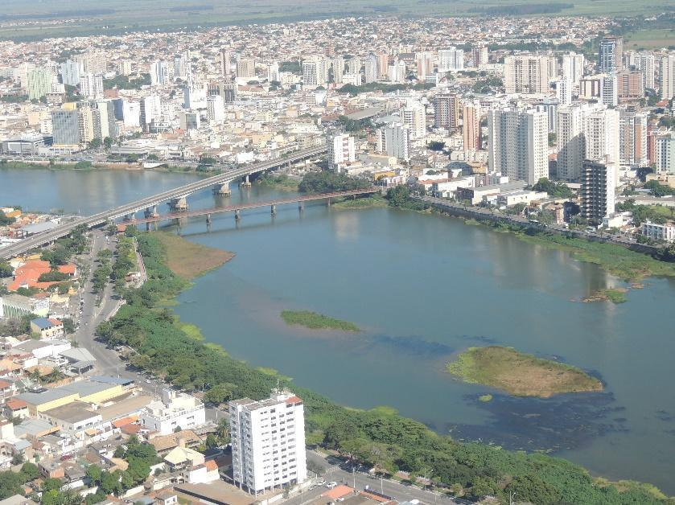
Source: Danielly Aliprandi, 2015.

2.4 Citations (Quotes) and notes
According to ABNT, any information from other authors must include the source. Quotations longer than three lines must be separated from the body of the text, denoted with two tabs, and written in Calibri font 10 (ten), as shown in the example below.

For quotations that exceed 3 lines of text, use Calibri font, regular, body 10, left alignment. Line spacing should be simple, with a paragraph indentation of 1.27cm and a 6-point space after each paragraph of your quote (Silva, 2011, p.5).

Notes should be inserted at the bottom of the corresponding page in Calibri font, body 10.
3 LAST POINTS TO PONDER
The work must be included in one of the thematic sessions of the 7th CIAP and must contribute to the event's objectives through its relevance, originality and topicality.
Full papers (excluding pre-textual and post-textual elements such as title, subtitle, abstract and references) should be between 6 (six) and 12 (twelve) pages long, containing no more than 2mb, in pdf format.
Papers accepted in their final version will only be published in the event's proceedings if at least one of the authors is registered for the event.
Only works cited in the article may be referenced in the "References" section. These must be in alphabetical order and follow the ABNT guidelines.
The event's current edition letterhead is required. The template is available for download on the event website.
Attention! Papers not in the format requested will not be evaluated/published.
ACKNOWLEDGEMENTS
Acknowledgements are not compulsory and should be included at the end of the main text. In the PDF version sent for evaluation, any information that could identify the work must be omitted.
REFERENCES
ASSOCIAÇÃO BRASILEIRA DE NORMAS TÉCNICAS. NBR 5706: Coordenação Modular da Construção– Procedimento. Rio de Janeiro: ABNT, 1977.
ALIER, Joan Martinez. Varieties of Environmentalism. London: Earthscan Publications Ltd, 1997.

Notes should be inserted at the bottom of the corresponding page in Calibri font, body 10.

